PART 1: WRITING THE EVALUATION OF RESEARCH PROCESSES
You’ve done your planning, it’s now time to WRITE!
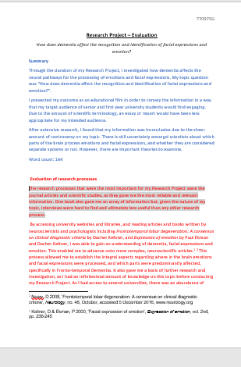
- THE FIRST PARAGRAPH.
Give a three – four sentence overview of all your research processes.
This summarises all your research processes and shows the marker that you understand that different research processes are more suited to some topics/questions than others. It gives them an understanding of your research journey.

- Eg. A wide range of research processes were utilised throughout my Research Project, including interviews, websites, blogs, YouTube videos and online informative articles. Due to the need for expert opinion to guide and support my choice of significant advancements, interviews and personal communications proved crucial for my topic. Sources such as Blogs and YouTube Videos were used early in my research, and provided background information but did not contribute at all to my Outcome. Ethically, I had to ensure I referenced all my sources and got permission to identify my interviewees, all of which were all granted.

- Eg. This research topic lent itself to gathering qualitative data and, of the many research processes undertaken, three stood out for their validity and usefulness. These three processes were interviews with farmers, particularly farmers over the age of fifty, statistical analysis of the data from the Bureau of Statistics and documentaries about climate change in Australia. However, other research processes also contributed
towards my research at particular times in terms of basic information and clarification.

- Eg. Qualitative research provided most of my information and this was appropriate given the nature of my question. Informational and organisational websites were only useful for establishing basic information and I found that most of my key findings emerged from interviews. However, quantitative research, in the form of the brief survey, was also important for cross-referencing.

- Eg. I obtained relevant and reliable information on my chosen topic through a variety of research processes. Books, interviews and blogs were pivotal research processes as they possessed content concerning both psychologically manipulative marketing strategies together with the ethical debate on manipulative marketing, both of which were integral to my question.

B. The other paragraphs (between 1100 – 1200 words)
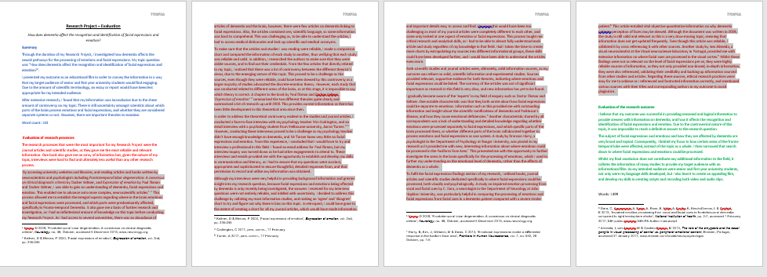

REMINDER: THINGS TO THINK ABOUT
For each paragraph, decide what aspects of evaluation you are going to focus upon – validity, reliability/usefulness, relevance/importance to your research, currency, representativeness, ethical practice

Each PARAGRAPH focuses upon a different research process eg. interviews, organisational websites, academic studies, surveys etc
Decide where you are going to include your information about your decision making. This link is an excellent guide to this performance standard. If you haven’t already read it, PLEASE READ IT!
https://www.sace.sa.edu.au/documents/652891/3860424/Research+Project+understanding+E2.pdf/55c62057-ebf9-4c0b-9963-cc96c35a97b1

REMEMBER: YOU DON’T NEED TO WRITE ABOUT EVERYTHING IN EACH PARAGRAPH
VALIDITY How appropriate was the process itself for the purpose of the research you conducted?
RELIABILITY/USEFULNESS How accurate and trustworthy the information was and why – this needs to be examined in detail. Look at the qualifications of the person who produced it, what was their purpose in producing the information.
RELEVANCE/IMPORTANCE Level and depth of information it provided on your topic or how it provided what became one of the key findings and/or how much it contributed to the research outcome.
CURRENCY How up-to-date is the source of information? To what extent does being up-to-date matter for your research?
REPRESENTATIVENESS How representative is the information from this research process?
ETHICAL PRACTICE What ethical practices did you need to follow?
EXAMPLES
X WHAT NOT TO DO! This is just a description at a ‘D’ grade

- I was very excited when I managed to organise a chance to go to a conference in Adelaide of a collection on women fire fighters. I was surprised at how many lady firemen there were and how much passion they had about their work and many of them were even volunteers. I wanted to speak to them about the controversial “stay or go” policy that many rural people have to think about hard. They were happy to talk to me and I trusted what they said as they had a lot of emotion and concern in their replies. They said that it was really a personal choice and that if you felt you were well prepared and had that right strategies in place to defend the house than many people chose to stay. However, they did say that there were a lot of many other things such as the weather and the geography of a place that people need to think about. I had a big issue with dealing with the emotional side of this topic and some of the stories they told me about recent tragedies in Australia and thinking about that big decision to defend your castle or flee.

TEACHER COMMENTS

- The problem here is that it just describes what the student did and what they found out.
- The student needs to analyse/make judgements about the research processes they used.

EXAMPLES (cont)

- Eg. The research processes that were the most important for my Research Project were the journal articles and scientific studies, as they gave me the most reliable and relevant information, together with one book that gave me an array of information. By accessing university websites and libraries, and reading articles and books written by neuroscientists and psychologists, including Frontotemporal lobar degeneration: A consensus on clinical diagnostic criteria by Dacher Keltner, and Expression of emotion by Paul Ekman and Dacher Keltner, I was able to gain an understanding of dementia, facial expressions and emotion. This enabled me to advance onto more complex, neuroscientific articles. This process allowed me to establish the integral aspects regarding where in the brain emotions and facial expressions were processed, and which parts were predominantly affected, specifically in Fronto-temporal Dementia. It also gave me a basis for further research and investigation, as I had an infinitesimal amount of knowledge on this topic before conducting my Research Project. As I had access to several universities, there was an abundance of articles of dementia and the brain, however, there were few articles on dementia linking to facial expressions. Also, the articles contained very scientific language, so some information was hard to comprehend. This was challenging as, to be able to understand the articles, I had to access medical dictionaries and look up scientific and medical acronyms.

TEACHER COMMENTS

- This student doesn’t just say which types of research processes were the most important but they distinguish exactly what made them important ie. Gave them the ‘most reliable and relevant information’, ‘gave me an array of information.’

- They give the title and author of particularly important sources.

- They show how one source of information led them on to another.

- They identify a challenge and show how they dealt with that challenge

EXAMPLES (cont)

- To begin my research I analyzed the Essentials Chemistry Workbook (7th edn.) by Christopher Evans, Mark McCann and Bob Morton. I had used this book whilst undertaking SACE stage 2 Chemistry in 2015 and an analysis of this text allowed me to revisit my knowledge on the topic, before beginning new research. Being a published text, recommended by SACE, this text gave highly reliable information on a relatively broad area. Similarly, the second source I analyzed, ‘Introduction to Organic Chemistry’, proved to be of exceptional reliability, due to the qualifications of the author, Dr. William Brown, who has achieved a Ph.D. in chemistry and the list of 16 professors of chemistry who have reviewed the text. It is appropriate to make a generalization in stating that the currency of sources relevant to my topic is effectively irrelevant to the validity of the information which they provide, as the information in relevant areas has remained largely unchanged for decades. For this reason, the validity of the text ‘Introduction to Organic Chemistry’ is not compromised by the 19 years since its publication. These first two sources were very extensive, providing in depth information on every aspect of my question, and allowing me to progress into analysing more specific sources.

TEACHER COMMENTS

- This is a good 2nd paragraph showing where the student began their research but it analyses as it describes.

- It clearly establishes the reliability of the sources, describing the qualifications of the writers

- It establishes that currency is not an important issue for this research topic

EXAMPLES (cont)

- Eg. I established that the true experts in my field were practising artists, the people at the easel most often. I created the opportunity to interview artists from varying backgrounds, gaining a wide array of perspectives and experiences. However, it was challenging to organise interviews given the demands on everyone’s time so I had to do some interviews by phone or email. My understanding of ethical research practises was increased as I had to ensure I gained permission from the artists to use their name and the information they provided. Art teacher, Cherie O’Dea and drawing lecturer Luke Thurgate gave examples of positivity they experienced, both in running their classes and in their personal lives. They highlighted the improvement of self-confidence and emotional release., Artist and psychologist Evy Moschakis detailed the psychological reasoning behind positive impacts of art making, especially the meditative state accomplished through repetitive movements and forgetting about any worries one might have. Jutta McMahon, seasoned artist of over fifty years, explained in detail her art making process and how it improves her life. All artists agreed on the incredibly therapeutic, freeing and healing impact art making generates, especially the strong release and absorption the practise induces. A large challenge was that most artists lived far away from me, so I resorted to phone calls and emails, yet I was able to interview one in person. Having the opportunity to converse over the phone and in person, I could clarify answers and ask follow-up questions to receive intricate data. Emails did not allow for this; therefore, they were more a Q&A instead and I was unable to acquire the same depth.

TEACHER COMMENTS

- First sentence shows the progression of the student’s thinking, having started with internet sources, they came to the realisation that the real ‘experts’ were practising artists.

- The student ‘created’ an opportunity

- The challenges and decision-making are described

- Student shows understanding of ethical research

- The strength of this paragraph is the demonstration of how a key finding was developed through interviews
EXAMPLES (cont)

- Eg. I was also able to access many books concerning space flight and the International Space Station but, despite the generally high validity of this research process, the nature of the information presented was relatively basic. The information was incredibly broad, and took a more generalised approach to suit its target audience of the general public and young students. This meant that this research process often failed to go into sufficient depth and expand on ideas. Books, such as the Encyclopaedia of Space and the World Book, were published prior to International Space Station’s completion in 2011 and therefore only focused on relatively older contributions to humanity. Currency was of paramount importance in my Research Project, as the International Space Station is still in operation today and the discoveries made a decade ago have been expanded upon since then. Therefore, while the information presented by these older publications is creditable, relevance is questionable and I could not rely on this research process to expand my findings.

TEACHER COMMENTS

- Student demonstrates an understanding of how the usefulness of books, however valid a research process, depends upon the target audience of the book.

- Student also demonstrates how the currency of information relates to the research topic

EXAMPLES (cont)

- A significant challenge I faced was trying to obtain the most relevant and useful information from lengthy books within a limited time-period. The Advertising Effect and Cashvertsing possessed information which was directly related to my topic, therefore obtaining information from these sources was very important to my research journey. The books challenged me to draw back from my new knowledge on marketing and psychology, in order to truly comprehend what was discussed within the books. To overcome the challenge of collecting large quantities of information from these sources within the time frame, I first skimmed over the books and took note of relevant subheadings. I then browsed over the appropriate headings and only stated key findings from each point in my Findings Chart. By locating and taking notes on the most relevant sections of the books, I was able to reduce the time taken to complete the source and was able to move on to corroborating information within the books with other research processes. Without utilising this strategy, it would have taken me over a week to read each book, which was unrealistic in terms of my deadline.

TEACHER COMMENT

- Sometimes a student has quite a significant challenge and this can be made into a paragraph on its own.

- The strength of this paragraph is in the detailed description of how the challenge was overcome, showing the development of the student’s skills and strategies.

Neary, D 2008, ‘Frontotemporal lobar degeneration: A consensus on clinical diagnostic criteria’, Neurology, no. 48, October, accessed 5 December 2016, www.neurology.org
Keltner, D & Ekman, P 2000, ‘Facial expression of emotion’, Expression of emotion, vol. 2nd, pp. 236-245
O'Dea, C 2017, pers. comm., 6 February.
Thurgate, L 2017, pers. comm., 13 February.
O'Dea, C 2017, pers. comm., 6 February.
Thurgate, L 2017, pers. comm., 13 February.
Moschakis, E 2017, pers. comm., 4 March.
Moschakis, E 2017, pers. comm., 4 March.
McMahon, J 2017, pers. comm., 15 March.
Couper, H & Henbest, H 2009, Encyclopedia of Space, 2nd edn, Dorling Kindersly Limited, London, England.
‘International Space Station’ 2009, in World Book, World Book, Chicago, vol. 10, pp. 346-347.
Ferrier, A & Fleming, J 2014, The Advertising Effect: How to Change Behaviour, Oxford University Press Australia and New Zealand, Australia.
Whitman, D 2009, Cashvertising: How to Use More Than 100 Secrets of Ad-Agency Psychology to Make BIG MONEY Selling Anything to Anyone, Career Press, United States of America.

